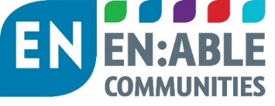

EN:Connect Employment and Skills in Communities Forum
#12
Tuesday 12 July 2022
14.00 -15.30

Venue Video meeting (MS Teams)

AGENDA

# | Time | Item | Presented by:
1 | 14.00 | Welcome  Introductions  Apologies | Simeon Perry Head of Operations  EN:Able Communities
2 | 14.05 | Case Study: WDH | Tim Craven  Social Investment Manager
3 | 14.25 | Health (disability) and Employment  - Policy context  - DWP initiatives – Access to work/Disability Confident/GP surgeries/Health Adjustments Passport/Work and Health Programme  - Working with local partners – local authority/providers  - Reed and South Yorkshrie Mayoral Combined Authority to provide examples ofsuccesses/initiativesand how landlords could help  - Q&A | Garth McLean  Parntership Manager, DWP North Central Team DWP  Case studies  Richard Hill  SYCMA  Andy Hunsley / Julie McNicholas  Reed
4 | 15.15 | National policy update  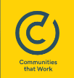 | Susanne Jobson  Karbon Homes  (Board member of Communities that Work)
5 | 15.25 | Future meetings  - Topics to discuss  - Seeking landlords to present topics of their good practice | Simeon Perry
 | 15.30 | Close

